Coding Challenge

# About SchoolBell.chat

SchoolBell.Chat is a collaboration platform for parents and teachers that promotes parent involvement. It is real-time, has a well-defined relationship control and guarantees privacy with a human connect. It is a “Slack” for Parents & Teachers.

# Product description

A real-time communication and collaboration platform and process for school, teachers and parents that is integrated with school management and learning management system. The triad, parent, children and teacher, are closely associated and influences each other much. A healthy relationship between parents and teachers can change the children’s attitude towards school, improve performance, and wellbeing. It could also boost a teacher’s morale and a parent’s confidence in their children. Considering the circumstances today, parents find it challenging to take time from work to meet teachers or for quality time with children. Teachers, on the other hand, are generally overloaded with work. A teacher should prepare for the class, do evaluations, attend the children needs and perform other administrative tasks. These reduce the frequency of communication between parent and teacher creating an information asymmetry.

Using this platform parent can communicate with teachers and vice versa using text messages, audio calls, and video calls. The platform is designed using microservices architecture. The front end is a progressive web app (PWA) using Angular 7. The microservices layer is developed using TypeScript and Node.js deployed on AWS Serverless platform. Some legacy code is developed using Java-Spring and deployed into Amazon’s ECS. The backend for the services is MongoDB and Redis. The entire Audio and Video communication use WebRTC framework.

# The challenge

The challenge is to develop a web-based employee management system satisfying preferably using open source technologies like the platform used in SchoolBell.chat. The employee management system will capture basic employee information detailed below.

1. Employee Id: A unique key to uniquely identify the employee within the organization.
2. Employee Name
3. Age
4. Gender
5. Department: Every employee will be associated with a department.
6. Manager: Every employee (except the president also an employee of the company) will have a manager whom the employee is reporting to.
7. Salary
8. Date of Joining

The system will have the functionality to search for employees based on name, department, age range, and manager name.

The contestants are free to make any assumption for the challenge as long as the assumption does not contradict basic requirements. All assumptions must be documented and explained why it was needed.

## Expected deliverables

All deliverables should be checked into source control and shared for review and assessment.

1. A solution architecture document explaining the high-level architecture
2. A high-level design documents
3. Source code
4. Unit testing with at least 75% code and branch coverage
5. Pitch deck

## Brownie points

1. End to end test automation
2. Security considerations during design and implementation
3. Performance considerations
4. Representation of design using sequence diagram, class diagram etc.
5. User experience and design thinking
6. SDLC Methodology

## Evaluation

All entries would be evaluated based on the following criteria

### Stage 1

Stage 1 will be an offline evaluation process

Evaluation Criterion:

1. Coding standards
2. Code quality
3. Database design
4. Design fundamentals
5. Solution architecture
6. Usage of source control repository
7. Pitch deck

### Stage 2

Four finalists from stage 1 will be selected for stage 2 will be a presentation-based evaluation process

# Timelines

Pitch workshop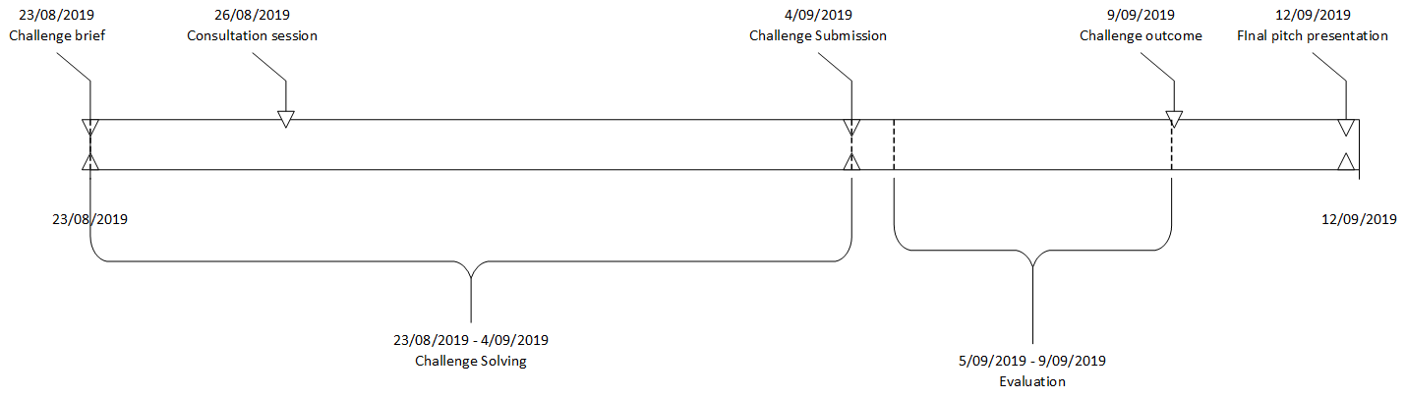

# Co-Founders

**Vinay Varma**: Vinay is the CEO and the co-founder of SchoolBell.chat, an education technology platform. He has more than 22 years of experience in the ICT industry spanning 7 countries. Over the years Vinay has worked as a developer to a senior manager leading large tech teams.

**Vijay Varma:** Vijay has more than 17 years of experience in Software Development in multiple development platforms. He has extensive experience working with agile methodologies and holds highly regarded Professional Scrum Master II, Professional Scrum with Kanban and Professional Scrum Product Owner I certifications and also works as Agile Coach\Scrum Master Coach, developing young software developers and testers to work in agile methodologies.